**5G/IOT TECHNOLOGY ADAPTATION STANCE**

Personal factor bias in decision making is future children planning-safe environment assistance.

**FOUR (4) Identified 5G/IOT Adaptation Concerns vs.**

1. Human Health and Planetary Environment Impact
2. Invasion of Personal Space/Violation of Human Privacy
3. Landscape Aesthetic Modification/Human Health
4. National Security Breach

**TWO (2) Benefactors:**

1. Industry Monetary Gain and Employment Security
2. Technological Advancement and Time-Saving Convenience
3. **Human Health and Environments Impact Concerns:**

**Belgium (EU-Governance): Radiation concerns halt Brussels 5G Network development.**

5G Pilot- Project fail Belgian Radiation safety standards.

https://www.naturalscience.org/news/2019/04/5g-blocked-in-brussels

**Switzerland** (**Country-UN): Monitor potential health risks posed by 5G Network Development**

<https://www.reuters.com/article/us-swiss-5g/switzerland-to-monitor-potential-health-risks-posed-by-5g-networks-idUSKCN1RT159>

**Health Risk-Microwave/RF (Radio Frequency) EMF (Electromagnetic Field) or Radiation Study:**

**Technological specifications and challenges:**

**5G Network Definition-**5G networks are [digital](https://en.wikipedia.org/wiki/Digital_signal) [cellular networks](https://en.wikipedia.org/wiki/Cellular_network), in which the service area covered by providers is divided into a mosaic of small geographical areas called *cells*.

Technical Data-[Analog signals](https://en.wikipedia.org/wiki/Analog_signal) representing sounds and images are digitized in the phone, converted by an [analog to digital converter](https://en.wikipedia.org/wiki/Analog_to_digital_converter) and transmitted as a stream of [bits](https://en.wikipedia.org/wiki/Binary_digit).

**New radio frequencies**

The air interface defined by 3GPP for 5G is known as New Radio (NR), and the specification is subdivided into two frequency bands, FR1 (below 6 GHz) and FR2 (mm Wave) _ each band with different capabilities.

**Frequency range 1 (< 6 GHz)**

The maximum channel bandwidth defined for FR1 is 100 MHz, due to the scarcity of continuous spectrum in this crowded frequency range. The band most widely being used for 5G in this range is around 3.5 GHz. The Korean carriers are using 3.5 GHz although some millimeter wave spectrum has also been allocated.

**Frequency range 2 (> 24 GHZ)**

The minimum channel bandwidth defined for FR2 is the 50 MHz and the maximum is 400 MHz, with two-channel aggregation supported in 3GPP Release 15. In the U.S., Verizon is using 28 GHz and AT&T is using 39 GHz. 5G can use frequencies of up to 300 GHz. The higher the frequency, the greater the ability to support high data transfer speeds without interfering with other wireless signals or becoming overly cluttered. Due to this, 5G can support approximately 1,000 more devices per meter than 4G.

[**5G**](https://en.wikipedia.org/wiki/5G) can include lower frequencies ([FR1](https://en.wikipedia.org/wiki/5G_NR_frequency_bands)), below 6 GHz, and higher frequencies ([FR2](https://en.wikipedia.org/wiki/5G_NR_frequency_bands)), above 24 GHz. However, the speed and latency in early FR1 deployments, using 5G NR software on 4G hardware

**FR2 Network coverage:**

[**5G**](https://en.wikipedia.org/wiki/5G)can use higher frequencies than 4G, and as a result, some 5G signals are not capable of traveling large distances (over a few hundred meters), unlike 4G or lower frequency 5G signals. This requires placing 5G base stations every few hundred meters in order to utilize higher frequency bands. At greater distances, these higher frequency 5G signals cannot easily penetrate solid objects, like cars, trees and walls, because of the nature of these higher frequency electromagnetic waves.

**The issues lies not as much in the Frequency range but rather the cell site w/ (Massive-MIMO-antennas) proximity to human inhabitance, open to high frequency levels of microwave exposure.**

**Current major** [**5G**](https://en.wikipedia.org/wiki/5G) **Sub 6GHz Deployments:**

The first fairly substantial deployments were in April 2019. In South Korea, [SK Telecom](https://en.wikipedia.org/wiki/SK_Telecom) claimed 38,000 base stations, KT 30,000 and LG 18,000; of which 85% are in six major cities. They are using 3.5 GHz (sub-6/non Mimo) spectrum and tested speeds were from 193 to 430[Mbit/s](https://en.wikipedia.org/wiki/Mbit/s) down. Verizon opened service on a very limited number of base stations in the US cities of Chicago and Minneapolis using 400 MHz of 28 GHz millimeter wave spectrum (MIMO). Download speeds in Chicago were from 80 to 634 Mbit/s. Upload speeds were from 12 to 57 Mbit/s. Ping was 25 milliseconds.[[4]](https://en.wikipedia.org/wiki/5G#cite_note-auto1-4)

**California Elementary School Cancer Outbreak:**

**USA-FOUR (4) WESTON ELEMENTARY CALIFORNIA STUDENTS AND THREE (3) TEACHERS DIAGNOSED WITH CANCER HAVING CELL PHONE TOWER ON CAMPUS.**

**Chronological collection of news proceedings on Weston Elementary Cancer circumstances:**

<https://ehtrust.org/fourth-student-has-cancer-parents-demand-removal-of-cell-tower-from-ripon-school/>

4G Close Proximity Concealed Cell tower removed from Weston Elementary School amid cancer concerns.

<https://www.kcra.com/article/cell-tower-to-be-removed-from-ripon-school-amid-cancer-concerns/26937925>

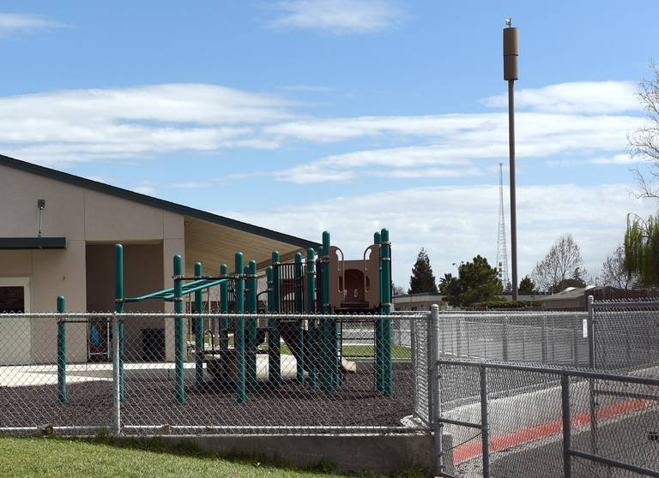

<https://www.modbee.com/news/article228538324.html>

**SMU School Cell Sites identified:**

[**Google Photo Search for concealed sector antenna**](https://www.google.com/search?q=concealed+sector+antenna&source=lnms&tbm=isch&sa=X&ved=0ahUKEwj__5inmP3hAhUERqwKHcAEAb4Q_AUIDygC&biw=1006&bih=606)



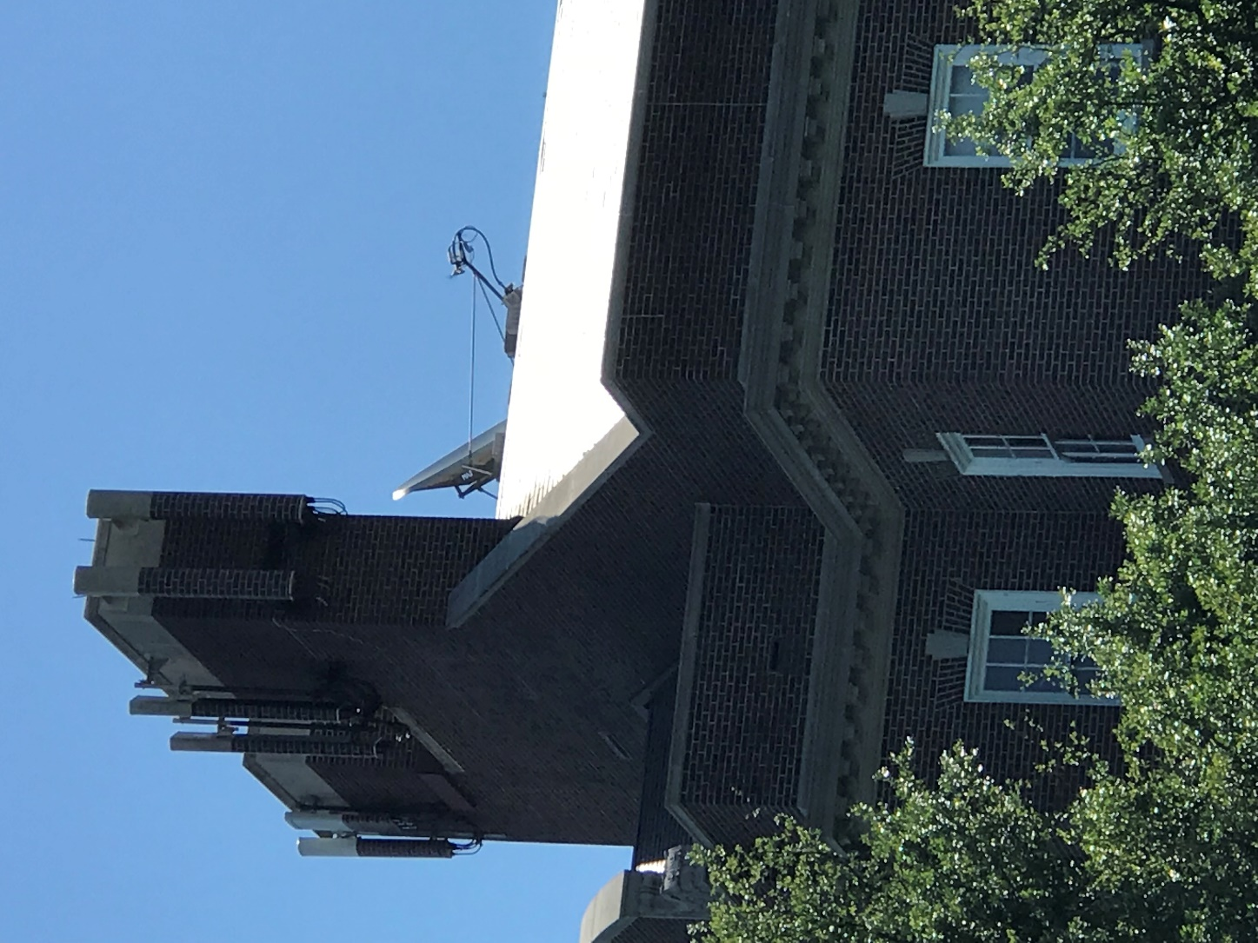

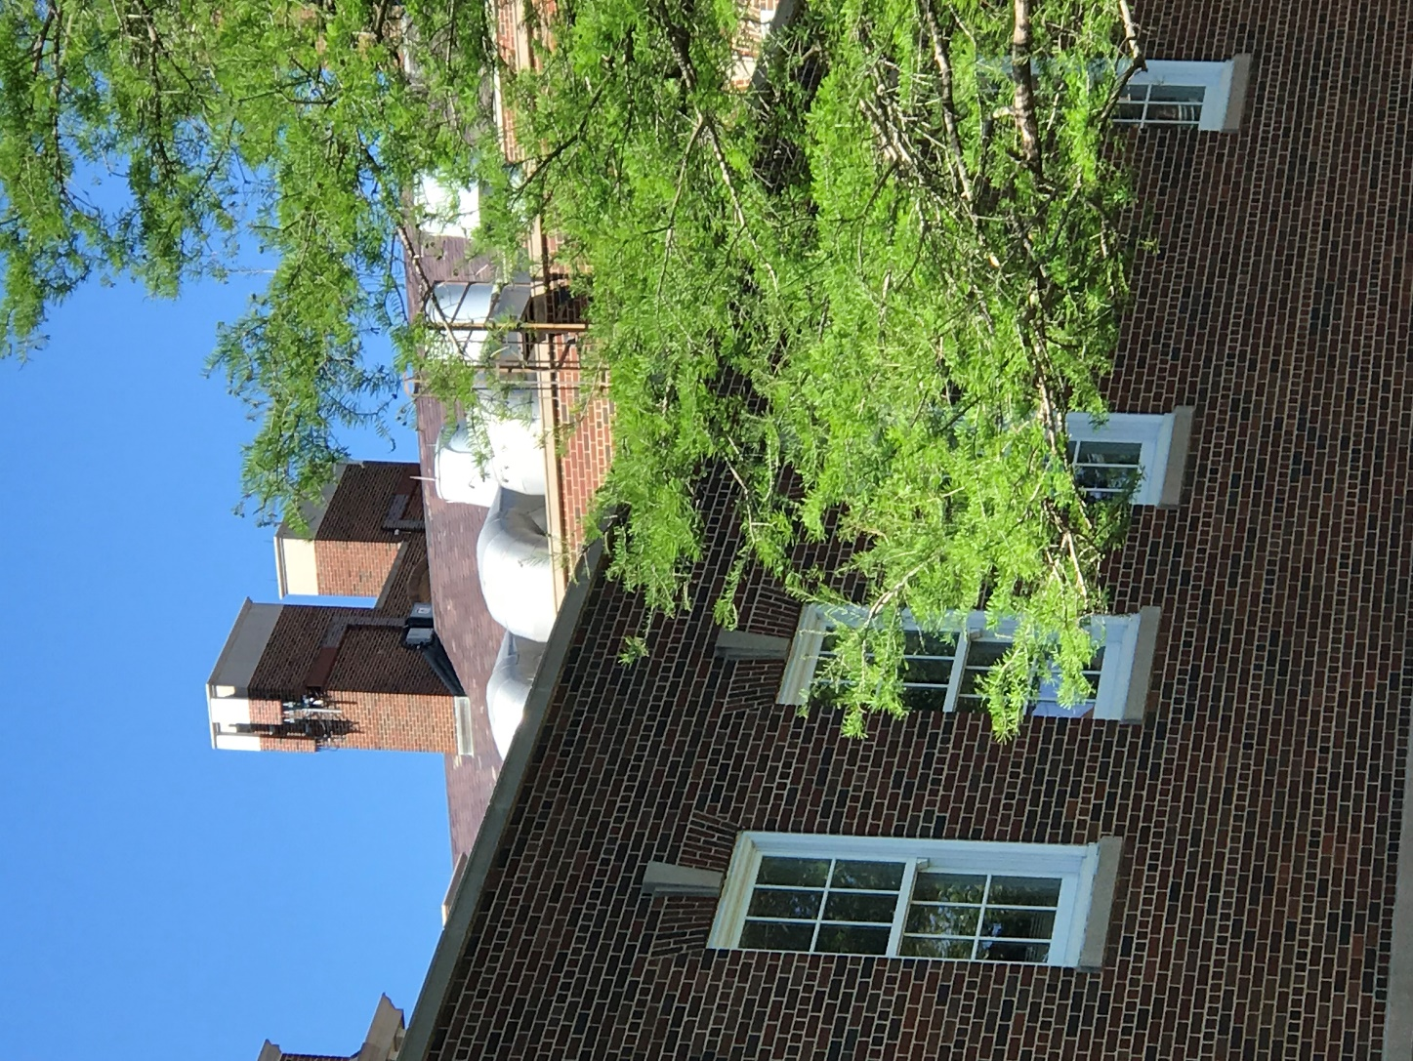

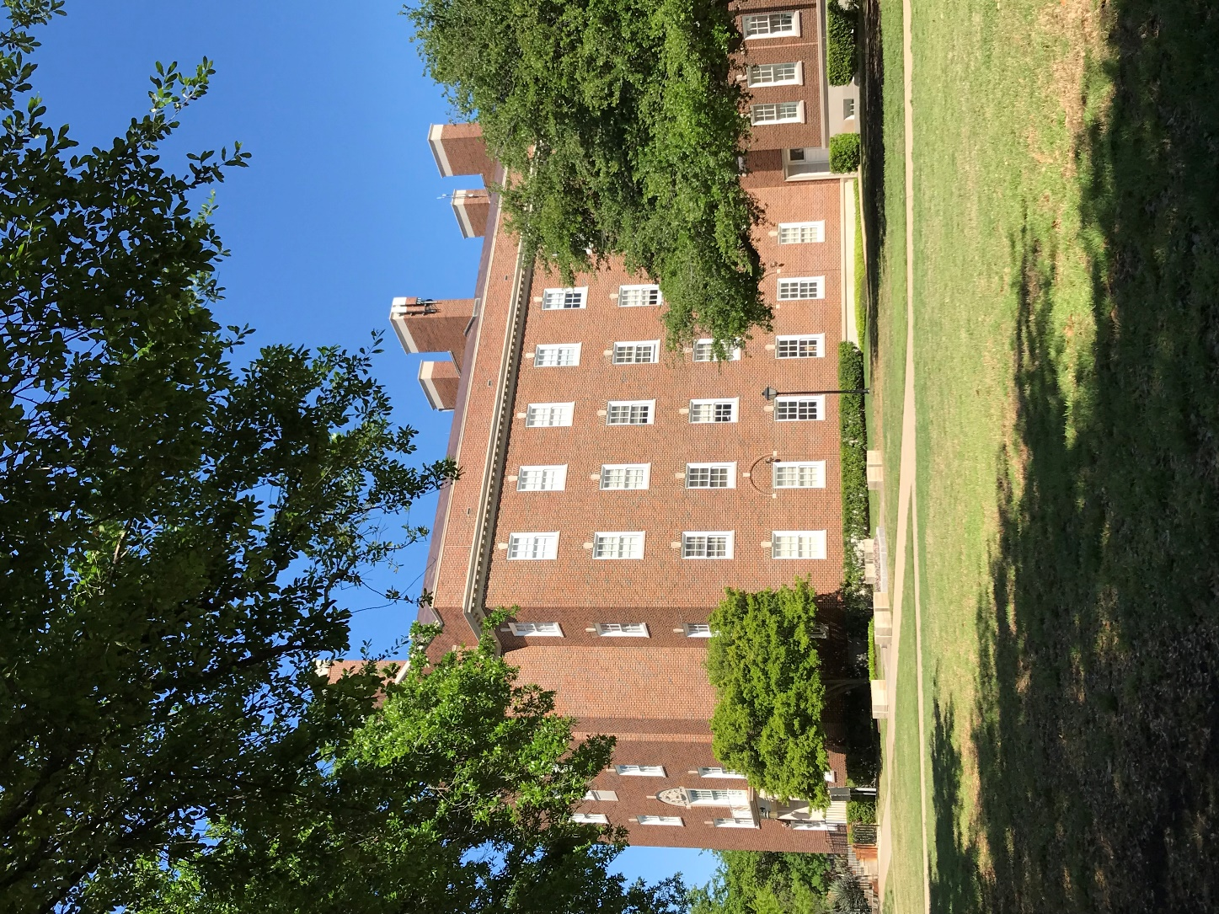

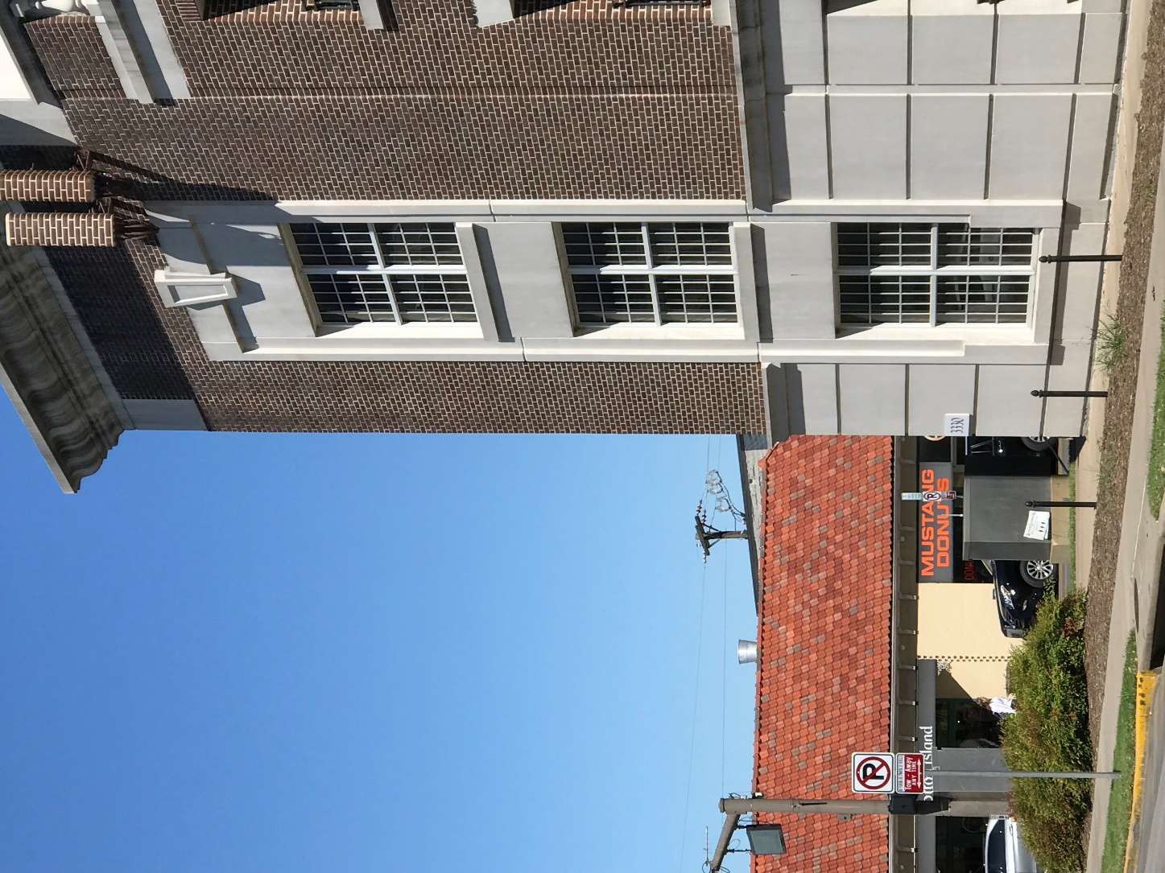

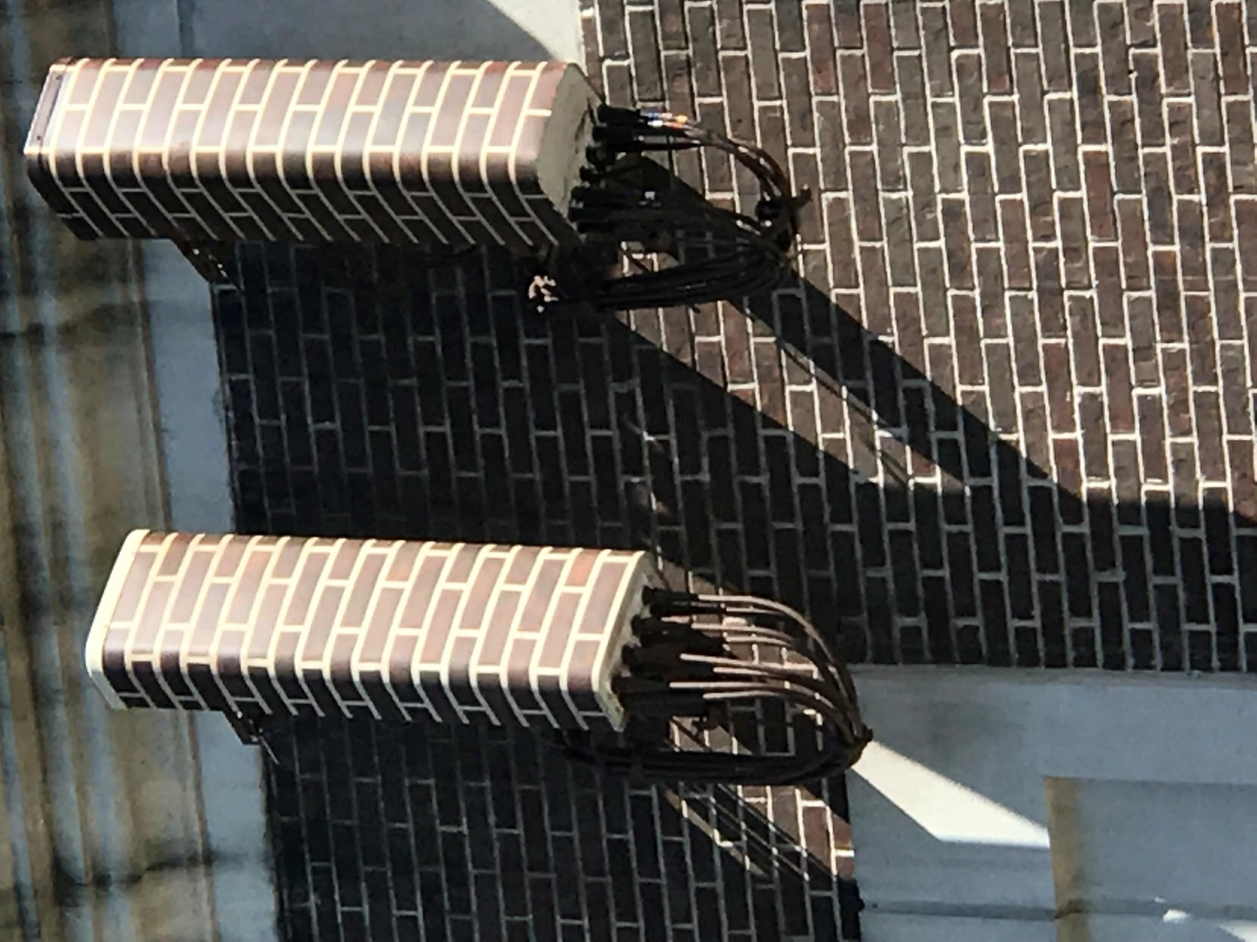

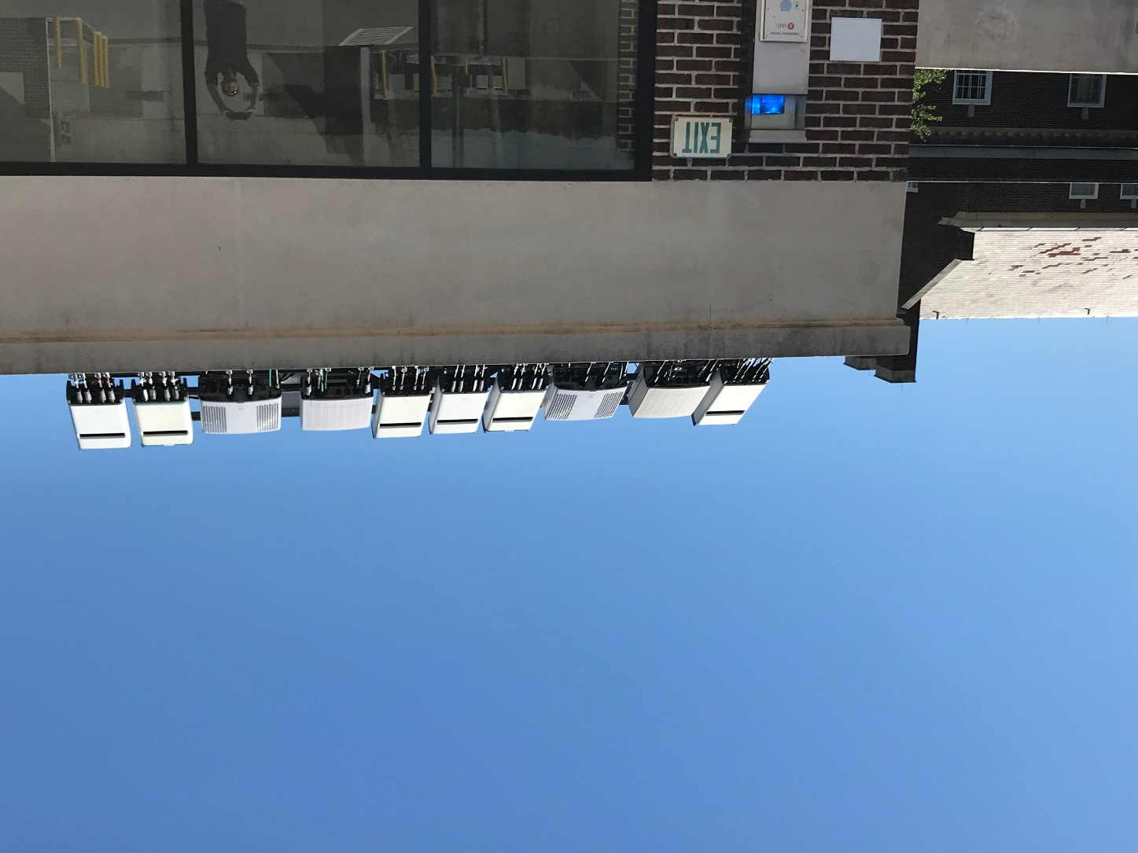

1. **Violation of Human Privacy/Invasion of Personal Space Concern:**

WHAT IS THE INTERNET OF THINGS?

The Internet of Things (IOT) is a vision of connecting every “thing” **possible** to the Internet – all machines, appliances, objects, devices, [**animals**](https://www.bbc.com/news/science-environment-45473786), even [**insects**](https://www.youtube.com/watch?v=TuLtaHU0bP8) and [**our brains**](https://www.wired.com/story/zuckerberg-wants-facebook-to-build-mind-reading-machine/?fbclid=IwAR2rt-nvVgZPALAQzqvwFmYa47VTVdIPGjRsgAU8nHrPk2qCTSGHpr-4x1Y). Every IOT “thing”, including robots, sensors, surveillance cameras, and augmented reality, personal data monitoring; mined, stored, and used by government, law enforcement, industry, and hackers.

Every IOT “thing”, including robots, sensors, surveillance cameras, and augmented reality, capable to increase human exposure to pulsed microwave radiation – known to adversely impact both [humans](https://www.ncbi.nlm.nih.gov/pmc/articles/PMC5607572/) and [wildlife](https://mdsafetech.org/environmental-and-wildlife-effects/).

<https://en.wikipedia.org/wiki/Internet_of_things>

**5G Network adapting Communication Satellites:**

5G cell tower antennas augmented by space based communication satellites. Source: [Starlink](https://en.wikipedia.org/wiki/Starlink_(satellite_constellation))

**Full Coverage Surveillance** prompts a **Controlled Digital Invasion** of personal human space leaving no room for privacy.

1. **Landscape Aesthetics Modification in close relations to Health Environment Concern:**

5G Tech. schema transfers higher millimeter wave (MMW) frequencies never before used for Internet and Telecommunications technology. These waves are unfit to travel through buildings at current tower proximities. Wireless telecom industry is seeking to outfit lampposts and utility poles around the country with wireless small cell antennas beaming hazardous radiation next to, and into our homes.

Wireless companies in the U.S. project to install about 300,000 new antennas – roughly equal to the total number of cell towers built over the past three decades. That's causing outrage and alarm in some neighborhoods, as antennas go up around homes. Health concerns about radiation emitted by the untested equipment.

<https://www.cbsnews.com/news/5g-network-cell-towers-raise-health-concerns-for-some-residents/>

Phased Array-Technology summary: Phased Array Antennas installed in cell phone, cell sites placed at close proximity and a wide range of space-orbiting satellites conduct a network communication by shooting mm-wave band beams of microwave radiation over Earth. Local urban community’s potential to maintain a cell site within close distances. **Experimental Hi-Frequency Microwave rays beamed by phased array antennas at close proximity passing thru the walls and human bodies creating health risks to humans and surrounding living habitat**.

<http://www.bell-labs.com/our-research/publications/299316/>

<https://www.ncbi.nlm.nih.gov/pmc/articles/PMC6211090/>

<https://phys.org/news/2018-06-ghz-transceiver-paves-future-5g.html>

<https://semiengineering.com/mimo-and-phased-array-antennas-for-5g/>

<https://scientists4wiredtech.com/what-are-4g-5g/5g-wavelengths-from-blankets-to-bullets/>

1. **National Security breach concerns:**

Huawei a Chinese company pursuing to become a major world supplier of 5G Technology equipment.

[Huawei Technologies](http://www.huawei.com/) (CHINA) products and 5G wireless network project bans; facing business contract restrictions and security scrutiny in various countries.

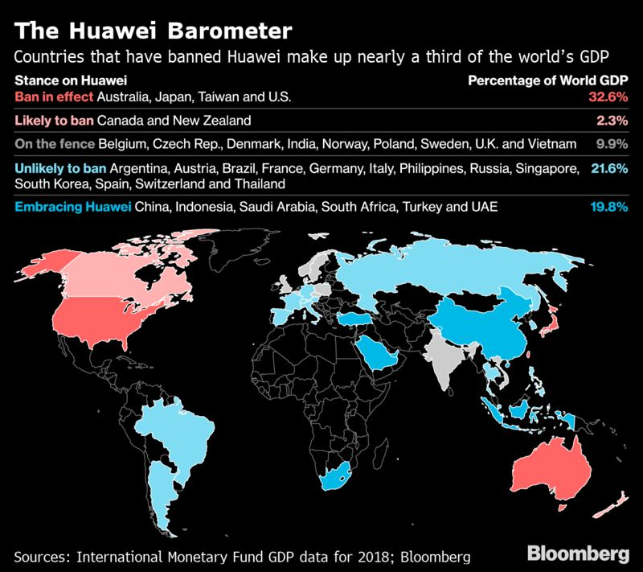

**Vodafone (UK) Found Hidden Backdoors in Huawei (CHINA) Equipment**

<https://www.bloomberg.com/news/articles/2019-04-30/vodafone-found-hidden-backdoors-in-huawei-equipment>

USA (Country)-President Trump:

Donald Trump is weighing an executive order to ban China telecommunications gear from U.S. networks.

<https://www.wsj.com/articles/rural-u-s-carriers-resist-proposed-chinese-telecom-ban-11549886402>

**Chinese technology poses a threat to critical US infrastructure.**

CHINA (Country)-President Jinping:

**China’s penetration into Europe’s Political Landscape.**

<https://www.bloomberg.com/news/articles/2019-04-03/china-s-influence-digs-deep-into-europe-s-political-landscape>

France (EU)-President Macron:

French President Emmanuel Macron quote “**Europe was wakening up to potential Chinese dominance in the region**”.

<https://www.cnbc.com/2019/03/27/eu-demands-scrutiny-of-5g-risks-but-no-bloc-wide-huawei-ban.html>

Germany (EU)-Chancellor Merkel: **Angela Merkel sets out condition for Huawei's participation in 5G network.**

<https://www.reuters.com/article/us-huwawei-europe-germany-merkel/merkel-sets-out-condition-for-huaweis-participation-in-5g-network-idUSKCN1PU0GZ>

Japan (Country)-Prime Minister Abe: **Japan effectively bans China’s Huawei and ZTE from government contracts**.Shinzo Abe cautions Europe's embrace of China 5G push.

<https://asia.nikkei.com/Politics/International-relations/Abe-presses-for-deeper-ties-to-slow-Italy-s-tilt-toward-China>

**Australia (**Country)-Prime Minister Morris:  **block Huawei (China), ZTE (China) from providing equipment 5G network.**

<https://www.reuters.com/article/us-swiss-5g/switzerland-to-monitor-potential-health-risks-posed-by-5g-networks-idUSKCN1RT159>

UK-(EU-BREXIT): Prime Minister May: Theresa May agreed to allow Huawei limited access to non-critical parts of the 5G network.

<https://www.reuters.com/article/us-britain-huawei-tech/uk-to-allow-huawei-limited-access-to-5g-networks-telegraph-idUSKCN1RZ2HD>

UK Defense Secretary Gavin Williamson fired over Huawei leak.

LATEST: **No decision has been made about Huawei (China)**

<https://www.cnn.com/2019/05/01/uk/gavin-williamson-defense-secretary-fired-huawei-leak-gbr-intl/index.html>

**FRANCE-GERMANY-UK required RESPONse TO European UNION (EU) COUNCIL:**

EU countries have until the end of June to evaluate 5G-related risks, leading to a bloc-wide Assessment deadline October 1, 2020.

<https://www.cnbc.com/2019/03/27/eu-demands-scrutiny-of-5g-risks-but-no-bloc-wide-huawei-ban.html>

**Technology Generation and RF/Microwave band levels** [**Diagram**](http://thesextantgroup.com/the-new-intelligent-building-iot-and-the-promise-of-5g-networks-by-senior-consultant-j-p-bonin/)**:**

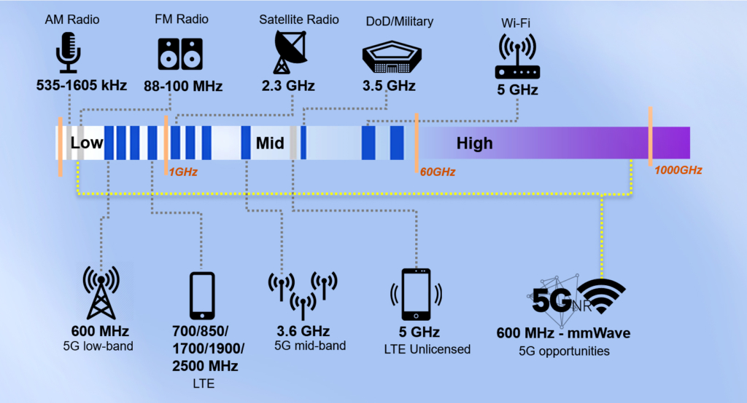

**National Toxicology Program Federal Study of tumor and cancers:**

Carcinogens Detected:

Breast Tumors

Glioma Brain Tumor

Meningioma Brain Tumor

Pituitary Tumor

Schwannoma Heart Tumor

Acoustic Neuroma Tumor

Parotid Gland Tumor

Thyroid Tumor

Eye Tumor

Melanoma Skin Cancer

The study was performed using modulation techniques of older generation GS and CDMA 900 MHz and 1.9 GHz. No studies have been done on more powerful 4G/LTE technologies which deploy 700-800 MHz and 1.7-2.7GHz frequencies.

<https://ntp.niehs.nih.gov/ntp/about_ntp/trpanel/2018/march/wyde.pdf>

NTP TOXICOLOGY REPORT 2 Year animal study display clear evidence pointing to clear evidence of EMF radiation capable causes cancer forming hazard.

Certainly no studies 5G 28-39 GHz millimeter waves licensed use and 64-79GHz millimeter waves for unlicensed use.

**Conclusive thoughts:**

Human bodies are electric. Every cell in humans’ body communicates using tiny electric signals, it is how the nervous system operates. Human heart and brain are electromagnetic organs. A healthy human heart produces an electromagnetic signal between 4 and 20Hertz. A healthy human body functions around 60-70Hertz. Right now 4G is using WIFI frequency of around 2.4GHz. (1 GHz = 1 Billion Hz). Even 4G WIFI starts to effect human body, as our bodies are filled up with 70 percent of water. To simply apply an exponential amount of microwave radiation into our environment and not feel the effect is simply false. The new 5G technology is taking a monstrous leap from the present 2.4GHz to anywhere between 6GHz and 79GHz. To put in perspective, 79GHz is 79 Billion electromagnetic waves, passing through the cells of a human body every second. We do not know much about the consumer health and environmental impacts of an IOT world. That is far from natural, and billions of times more than what is safe for the human body to be constantly be bombarded with. This 5G wireless broadband technology uses a different type of shorter (millimeter) wavelength known as radio-frequency microwave radiation, and we are woefully uninformed to understand its impacts on humans, insects, animals and the overall environment of our communities where the proliferation of these small cells installments.

**5G is being rolled out prior to an adequate human exposure bio-medic lab research study.**

**We have to be certain beyond a reasonable doubt that this new technology is made safe.**

**5G Technology Implementation Tests Positive on Four (4) Categorized concerns. Unable to outweigh the Two (2) Categorized benefits.**

**Modeling Proposal:**

**Create a map displaying Huawei 5G Equipment spread and countries for and against the rollout of the China Technology.**

Build Charts to Display the relationship with given Datasets:

* Rat Cancer Cases vs Time
* Human Cancer Cases vs Time
* Mobile Subscriber Connections vs Time
* Cell Site vs Time
* Human Cancer Cases vs Cell Sites
* Human Cancer Cases vs Mobile Subscriber Connections

Build California Cancer School Image Identifier to compare and search on possible keys:

* Concealed Sector Antenna
* Small Cell Sector Antenna
* Concealed Antenna Node
* Stealth Sector Antenna
* Camouflaged + small cell tower or sector antenna

**Example search link:**

<https://www.google.com/search?q=concealed+sector+antenna&source=lnms&tbm=isch&sa=X&ved=0ahUKEwj__5inmP3hAhUERqwKHcAEAb4Q_AUIDygC&biw=1006&bih=606>

Build a predictive model:

Applying Linear Regression formula, our model can predict the future cancer occurrence growth from the anticipated cell sites major expansion illuminating EMF radiation, in case of a current plan of a 5G Technology FR1- sub 6GHz(Low Frequency) / FR2 - 6-79GHz (High Frequency MM-wave MIMO) roll out is going forward without additional test studies.

Datasets links:

**CTIA Wireless Subscribers and Cell Sites Industry Annual Survey Results 2000 to 2016** (table page scroll the bottom):

<https://api.ctia.org/wp-content/uploads/2018/07/CTIA_ToplineWirelessIndustrySurvey.pdf>

**NTP FEDERAL SPONSORED TOXICOLOGY AND CARCINOGENESIS STUDIES** SPRAGUE DAWLEY SD RATS EXPOSED TO WHOLE-BODY RADIO FREQUENCY RADIATION AT A FREQUENCY (900 MHz) AND MODULATIONS (GSM AND CDMA) USED BY CELL PHONES, 2 YEAR STUDY, FINAL REPORT NOV. 2018(page 14-15 provide carcinogens equivocal by-numbers data):

<https://www.niehs.nih.gov/ntp-temp/tr595_508.pdf>

Additional NTP detailed animal data (2yr Individual data, select Male and Female Neoplastic Pathology Data):

<https://manticore.niehs.nih.gov/cebssearch/data/publication/TR-595>

**Center for Disease Control - U.S. New Cancer Patient Annual Statistics 2001-2016 (**Page 14-16**):**

<https://www.cdc.gov/cancer/uscs/public-use/pdf/npcr-seer-public-use-database-data-dictionary-2001-2015-508.pdf>

**Global Burden of Disease Study (Estimated Data/Non-federal Source)-US Total Cancer Patient Statistics 1990-2017:**

<https://ourworldindata.org/cancer>

**SPRAGUE DAWLEY SD RATS LIFESPAN:**

<https://www.taconic.com/pdfs/sprague-dawley-rat.pdf>